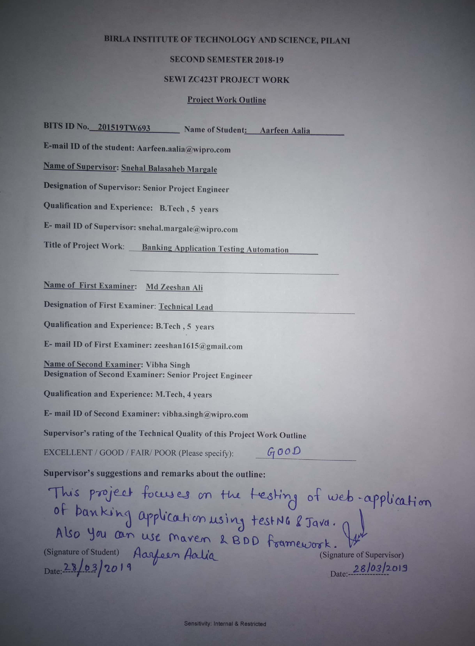

**Contents:**

BIRLA INSTITUTE OF TECHNOLOGY AND SCIENCE PILANI (Rajasthan) India 0

Contents 0

Introduction 3

Scope of work 4

Methodology Used 5

Benefits expected from the work 6

Plan of work: 7

# Introduction

This Application will provide user friendly User Interface to the tester which will test Banking Applications and it will generate report containing logs in a well-documented format.

Application will help to reduce the number of bugs found in later phase of software life cycle.

Most importantly, this can help manual testers and facilities them to execute large number of test cases in short period of time. This will increase the efficiency and productivity of testers, hence will reduce the project’s overall cost.

# Scope of work

* The primary objective of this project is to minimize the physical efforts and improve the tester productivity.
* This project will generate test report in a well-documented format which can be referred in future as well.
* This project will reduce the manual error done while testing the sensitive applications.
* This project will also help to track the bugs and defects found most often.
* This project is a step towards saving time on testing application.

# Methodology Used

As this work involves extensive study of Bank functionalities and testing tools, following are the steps to achieve the required understanding:

* Referring to Bank Application used in the project and create a dummy similar Application.
* Study of all banking functionality used in Bank Application.
* Analyzing the individual functionality of each application and understanding the testing requirements.
* Creating test case to automate the manual process used to test the Application.
* Executing the test case, generating reports in documented format.

# Benefits expected from the work

* + - Helps to find bugs in the early stages of software development.
    - Higher Overall Test Coverage
    - Reduces expenses and working hours to fix these problems
    - Increases the overall software efficiency and ensures robust software quality.
    - reduce the time-to-market of an application
    - Maintains Information Security.

# Plan of work:

|  |  |  |  |
| --- | --- | --- | --- |
| **S.**  **No** | **Task to be done** | **Planned duration (weeks)** | **Specific Deliverables in terms of the project** |
| 1 | Requirement Gathering | 2 | Gathering information about the functionality of banking application. |
| 2 | Analysis | 3 | Identify and determine the items which need to be tested |
| 3 | Design | 3 | Design the [test strategy](https://www.softwaretestinghelp.com/writing-test-strategy-document-template/) |
| 4 | Development | 6 | Building the test cases. |
| 5 | Testing | 2 | Regression testing on web application. |